HATS IN THE RING

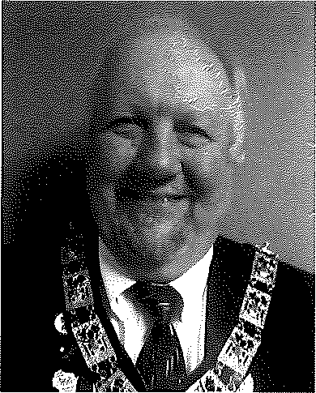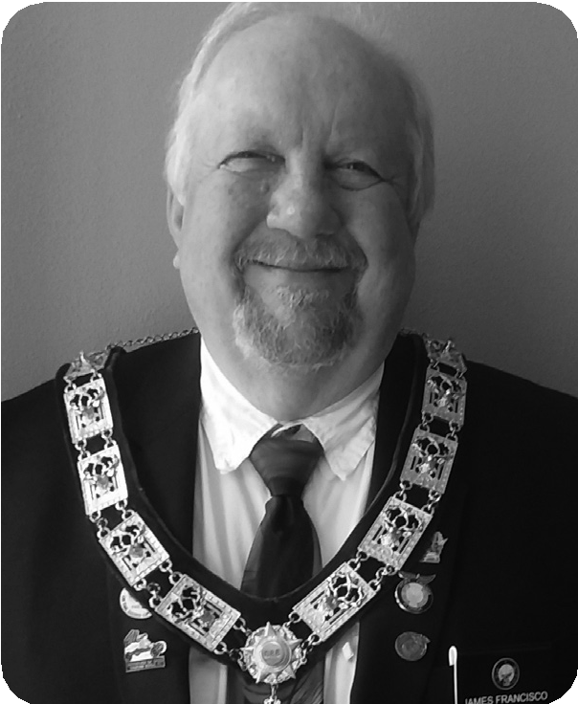 Hats In The Ring for
VICE-PRESIDENT CENTRAL

Candidate for the office of
VICE-PRESIDENT CENTRAL
Wisconsin Elks Association
JIM FRANCISCO
Baraboo #688
Hats In The Ring for
VICE-PRESIDENT NORTHWEST
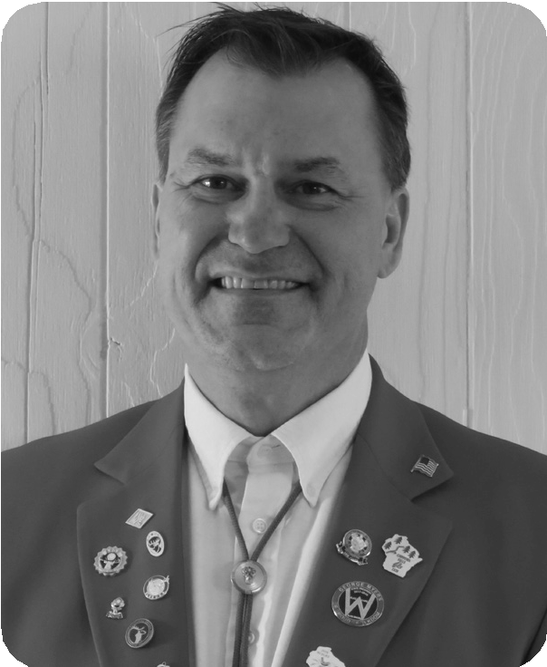
Candidate for the office of VICE-PRESIDENT NORTHWEST
Wisconsin Elks Association
GREG MAZUR
Chippewa Falls #1326

Hats In The Ring for VICE-PRESIDENT NORTHEAST
Hats In The Ring for VICE-PRESIDENT SOUTH

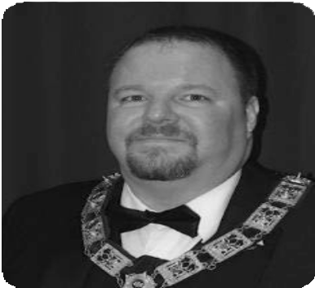

Candidate for the office of VICE-PRESIDENT NORTHEAST
Wisconsin Elks Association
BRUCE CONARD
Wausau #248
Candidate for the office of
VICE-PRESIDENT SOUTH
Wisconsin Elks Association
JASON SOMERS
Waukesha #400

HATS IN THE RING
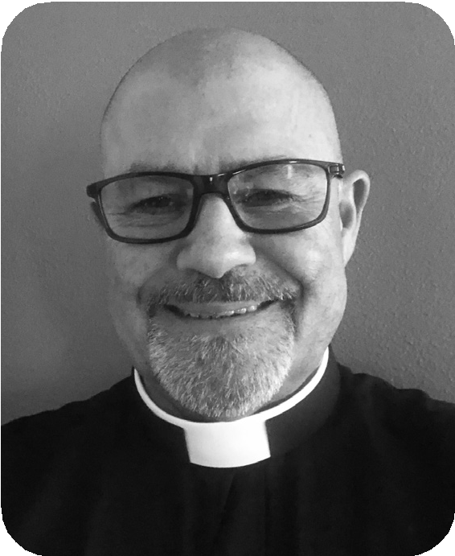
Hats In The Ring for
STATE CHAPLAIN
Candidate for the office of
STATE CHAPLAIN
Wisconsin Elks Association
MICHAEL HACKBARTH
Sheboygan #299
Hats In The Ring for
Hats In The Ring for
STATE TRUSTEE SOUTH

Candidate for the office of
STATE TRUSTEE SOUTH
Wisconsin Elks Association
DAVID DeROSIER
Milwaukee #46
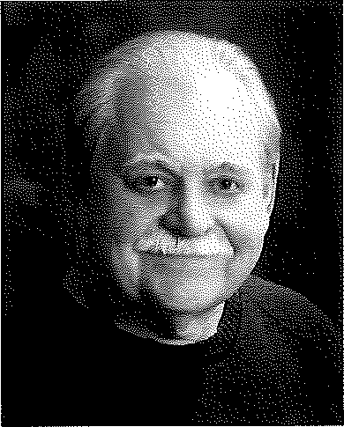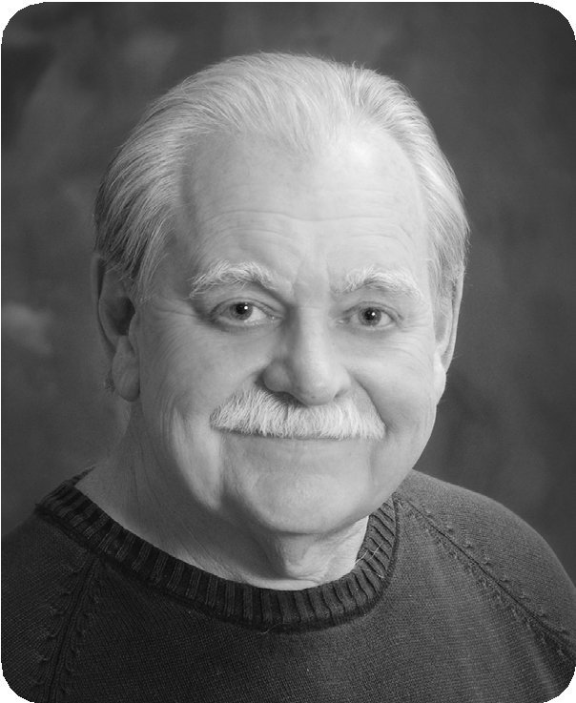STATE TRUSTEE AT-LARGE

Candidate for the office of

STATE TRUSTEE AT-LARGE

Wisconsin Elks Association

ANDY OLANDER
Marshfield #665

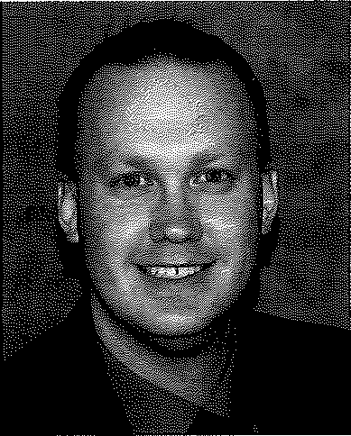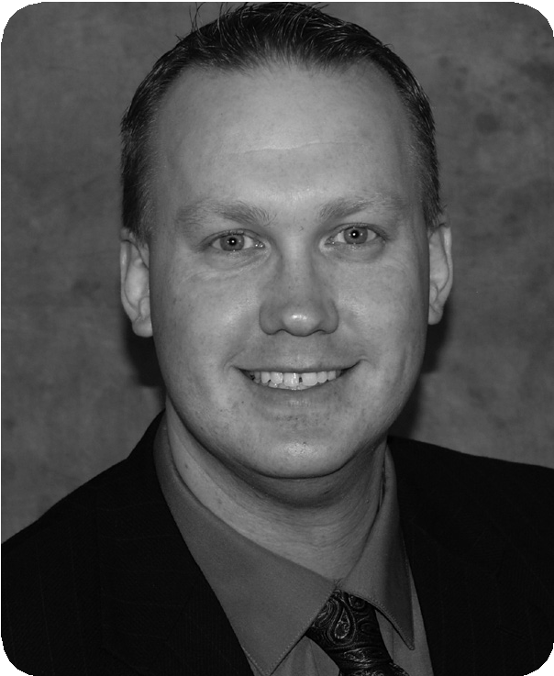Hats In The Ring for STATE INNER GUARD

Candidate for the office of STATE INNER GUARD
Wisconsin Elks Association
RYAN SWANTZ
Watertown #666
Hats In The Ring for STATE SECRETARY
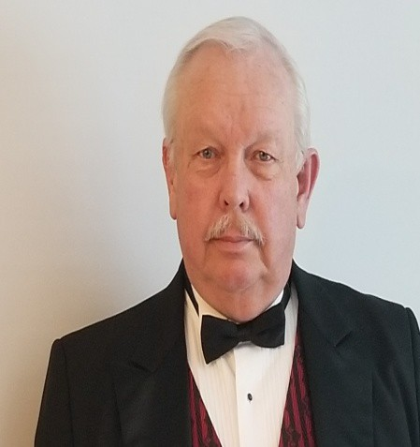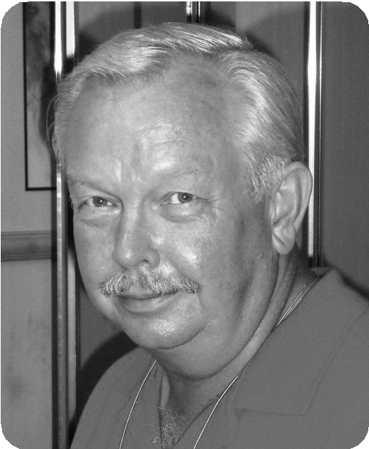
Candidate for the office of STATE SECRETARY
Wisconsin Elks Association

KEN JOHNSON
Wausau #248

HATS IN THE RING

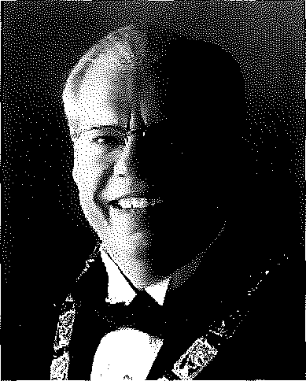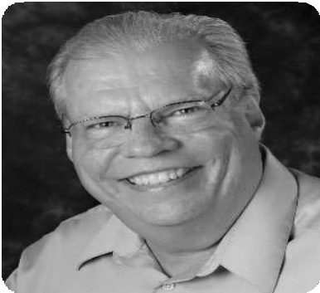 Hats In The Ring for
STATE PRESIDENT-ELECT

Candidate for the office of
STATE PRESIDENT-ELECT
Wisconsin Elks Association

DAVE HAGEN
Janesville #254
Hats In The Ring for
STATE PRESIDENT-ELECT
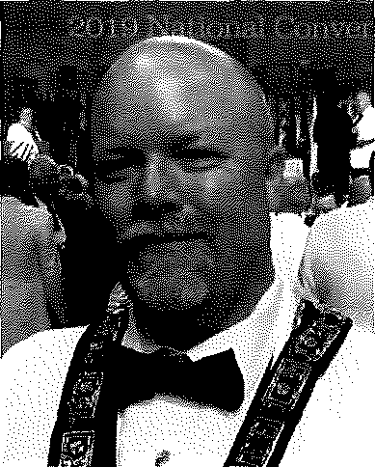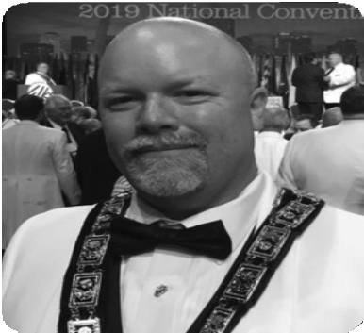
Candidate for the office of
STATE PRESIDENT-ELECT
Wisconsin Elks Association

KARL HANKE
Wausau #248

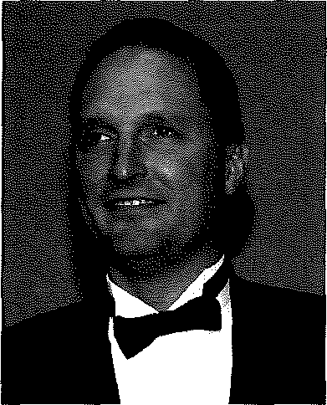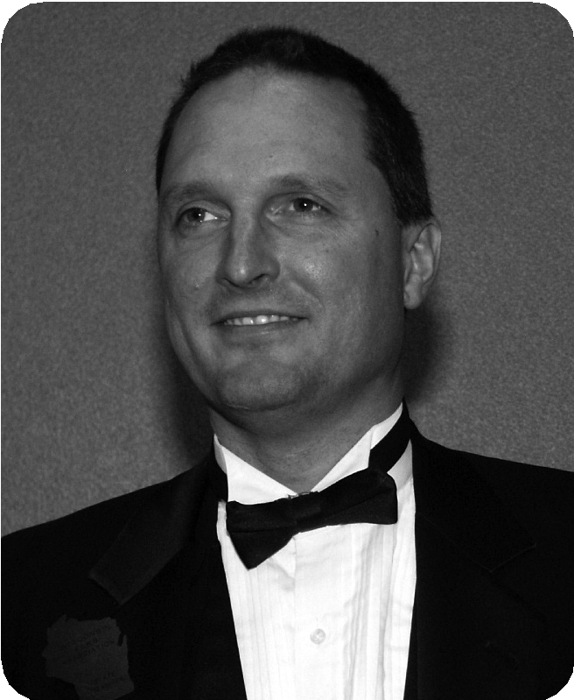 Hats In The Ring for
STATE TREASURER

Candidate for the office of STATE TREASURER
Wisconsin Elks Association

JEFF LANGTON
Waukesha #400
Hats In The Ring for
STATE SERGEANT-AT-ARMS

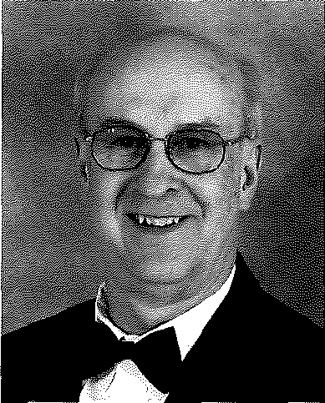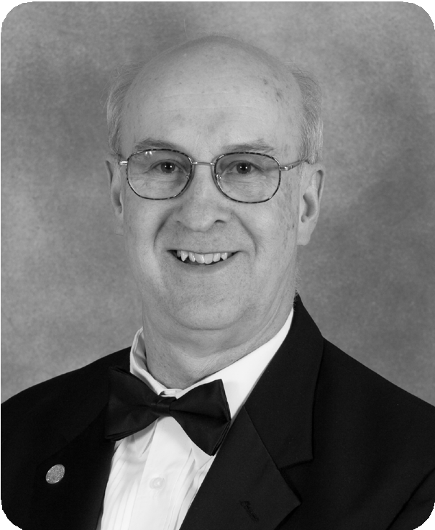
STATE SERGEANT-AT-ARMS
Candidate for the office of
Wisconsin Elks Association

DON BEHNKE
Sheboygan #299

HATS IN THE RING

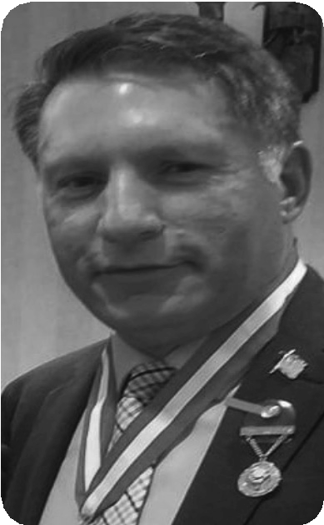Hats In The Ring for STATE STATE TRUSTEE CENTRAL

Candidate for the office of STATE TRUSTEE CENTRAL
Wisconsin Elks Association
TONY VOULGARIS
Oshkosh #292
Hats In The Ring for
STATE TRUSTEE SOUTH

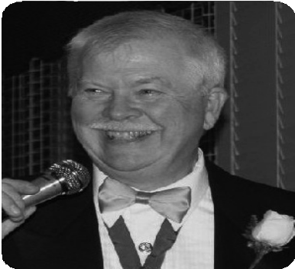
Candidate for the office of STATE TRUSTEE SOUTH
Wisconsin Elks Association DAVID DeROSIER
Milwaukee #46

Hats In The Ring for STATE TILER
Candidate for the office of STATE TILER
Wisconsin Elks Association
NIKKI SHANNON
Beaver Dam #1540

Hats in the Ring for
STATE TRUSTEE AT-LARGE
Wisconsin Elks Association
ROB RADIG, SR.
Beaver Dam #1540

